

Restaurant management; Progress report 2
Yasir Almutairi
03/09/2018

Project Overview
The restaurant business is so far going well, making milestones in since its launch. We have managed to employ permanent staff and put into place systems that ensure the point of sale, accounting and business service are on point. Consumers have expressed satisfaction with speedy service reducing the amount of time they spend in the restaurant halls. Employee reimbursement, however, has become a hurdle attribute to the increasing demand for human resource management due to increasing permanency of employees. The system earlier set was suitable for temporary employment that does not consider fulltime occupations. Employees are raising concerns over the inequity of reimbursement, late payments, inconsistent system of payment and insurance coverage. It is therefore imperative that I look into the matter and find an innovative solution to the case.
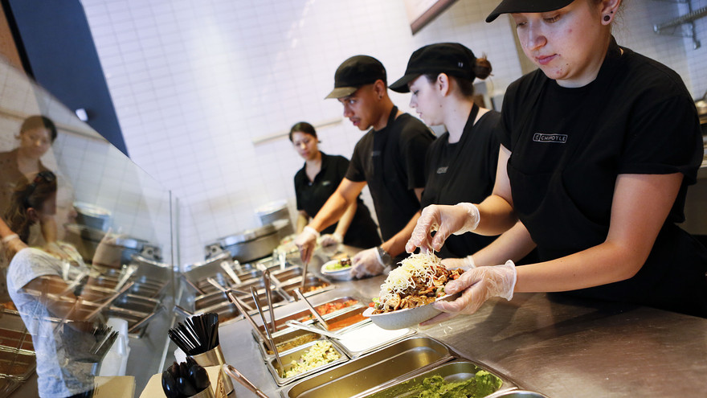
Project goal
At this stage, based on the current challenges, the goal we have set is to create dependable hiring, assigning and human resource management system in the restaurant. It is crucial we take care of our employees as they will sell the brand of our restaurant.
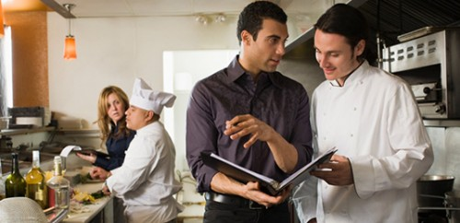
The better the organization culture acquired form better compensation and working environment, the better the services offered to our consumers, the lower the consumer turnover and the profitability of the restaurant. The system will assign roles to each occupation, the wage level of each occupation, the appraisal standards, the relation of each profession to other profession and the benefits received. Career advancement paths and promotion standards shall also be set I the system.
Project approach
project approach
The restaurant is putting all effort to research develop a suitable human resource management system that will set a clear career path and employee relations in the restaurant. I have set aside particular group tasked to come up with the system with the help of a newly employed human resource manager in supervision.
Expected results
With constants increase in the performance metrics accomplishment rates, it is in our hopes that the changes effected in the restaurant organizational culture and the human management system will make the restaurant even more profitable.
Resources


Despite limited capital resources, it is expected that with efficient budgeting the, operational capital of the restaurant will cover the resources necessary to carry out the desired initiatives. The human capital required is insourced therefore not costly. The stationary and many other materials used in the research and development of the human resource management system will be covered in the kitty account.
Assumption
It is assumed that the employees will remain in service in the restaurant during the period of the development of the system. The needs and requirement for employment will remain constant in the market under the legal and forces of the economy.
Milestone
Sales throughout other days of the week are to increase probably within the first month of relative changes and overall sales to be realized with profits later.
Limits and exclusions
This is a new business venture, and not much of profits is yet to be realized. This has proven to be a challenge even in endorsing other ideas and also the fact that it is under sole proprietorship which limits my access to new ideas instantly, but maybe with time a lot of profits will be realized as I incorporate other stakeholders.
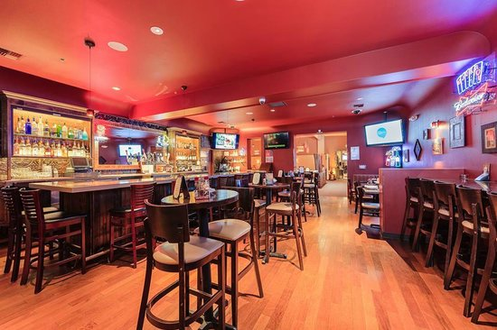

References
Giousmpasoglou, C. (2016). Hotel and restaurant management education.
Han, H., & Hyun, S. S. (2017). Impact of hotel-restaurant image and quality of physical-environment, service, and food on satisfaction and intention. International Journal of Hospitality Management, 63, 82-92.
Ruiz-Molina, M. E., Gil-Saura, I., & Berenguer-Contrí, G. (2014). Information and communication technology as a differentiation tool in restaurants. Journal of Foodservice Business Research, 17(5), 410-428.
Silva, J. (2017). U.S. Patent No. 9,805,401. Washington, DC: U.S. Patent and Trademark Office.
Walker, J. R. (2013). The restaurant: from concept to operation. Wiley Global Education.
Zheng, C., & Forgacs, G. (2017). The emerging trend of hotel total revenue management. Journal of Revenue and Pricing Management, 16(3), 238-245.

